Year 8 Earth and Beyond Quiz 1

Name: ____________________________ Mark: _______/15

- Label the layers of the Earth on the following diagram.
(4 marks)
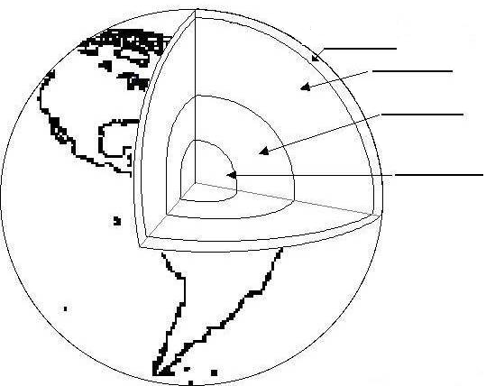
crust
mantle
outer core
inner core

- Write the term that corresponds to each definition below
(4 marks)
outer core
___________________ A 2260km layer of very dense liquid at high temperature.
mantle
___________________ A very dense solid layer which behaves like a fluid
crust
___________________ A thin outer layer about 100 kilometres thick which moves in sections called plates
inner core
___________________ A solid mass about 1220 kilometres thick. It is kept solid by the tremendous pressure that exists at this depth.
- What does the term ‘Plate Tectonics’ mean?
(2 marks)

Movement of the crustal plates of the Earth

- What causes the crustal plates to move?
(2 marks)

Convection currents in the mantle

- Give three examples of evidence scientists have that the continents are drifting apart.
(3 marks)
Similar fossils on two continents separated by an ocean
Snapped telephone cables under the ocean
Rocks and minerals similar on two continents separated by an ocean

